**Data Engineering Assignment-3**

**Question:** Commands in SQL

**Answer:**

There are different types of languages in SQL. They are:

* DDL (Data Definition Language):
* DML (Data Manipulation Language):
* DCL (Data Control Language):
* **DDL (Data Definition Language):**

DDL allows us to define what the structure of our databases looks like. DDL statements are used to define, manage and control the structure of a database. The statements are responsible for creating, altering and deleting database objects.

The DDL commands are:

* **CREATE:** This command is used to create a new table in database.

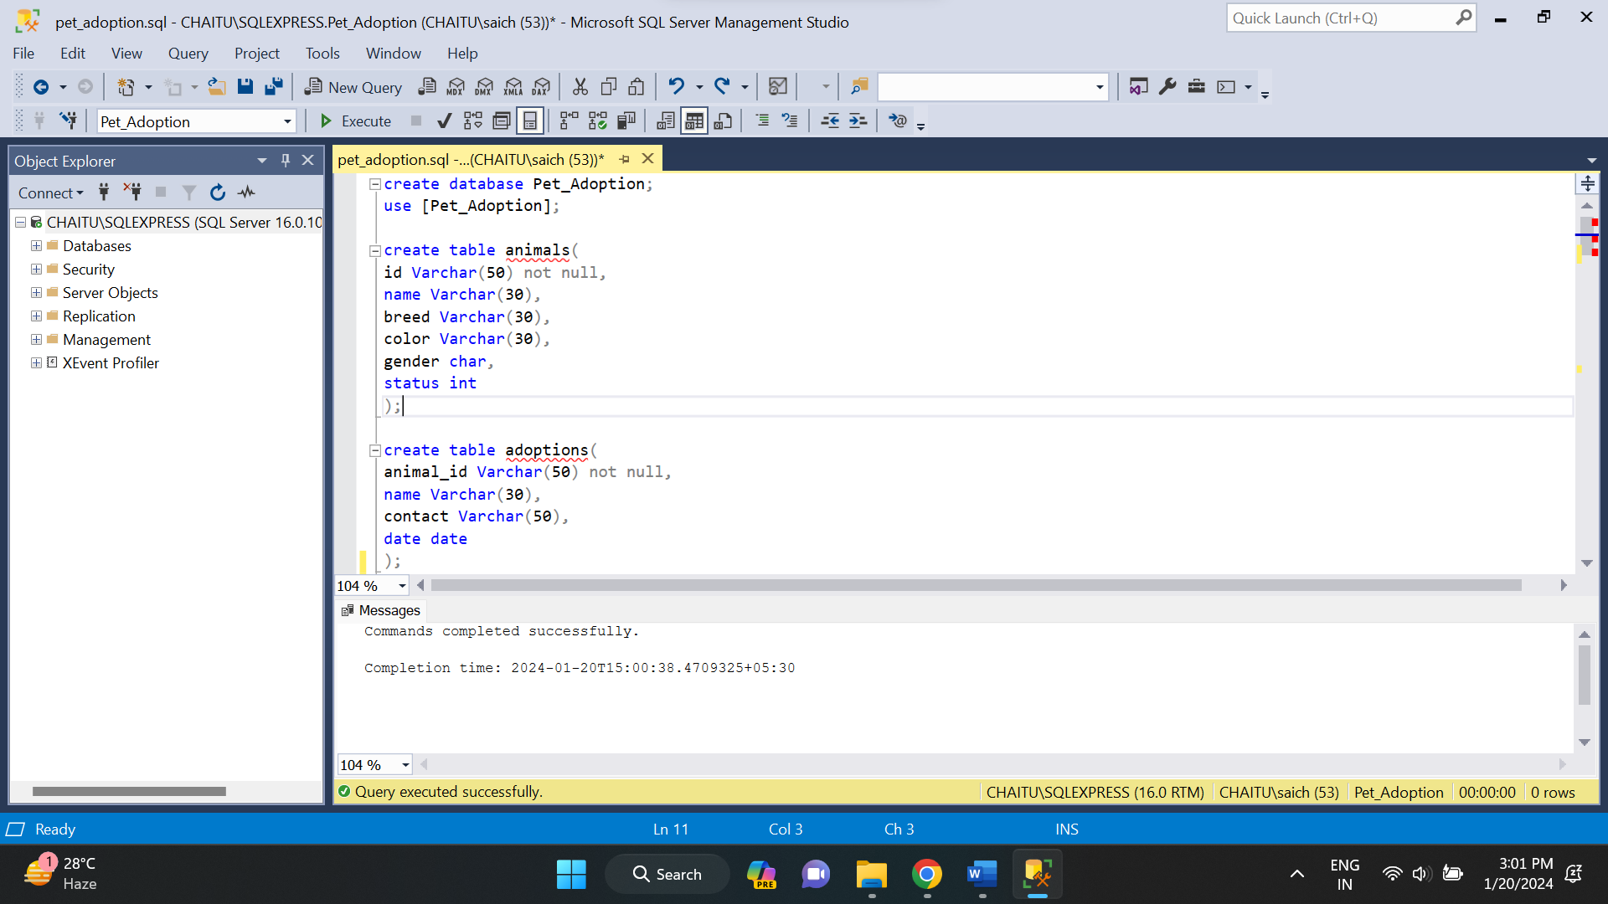

In the above example, I have created a pet adoption database and I have created animals and adoptions tables.

* **ALTER:** This command is used to modify an existing table, such as adding, modifying or dropping columns.

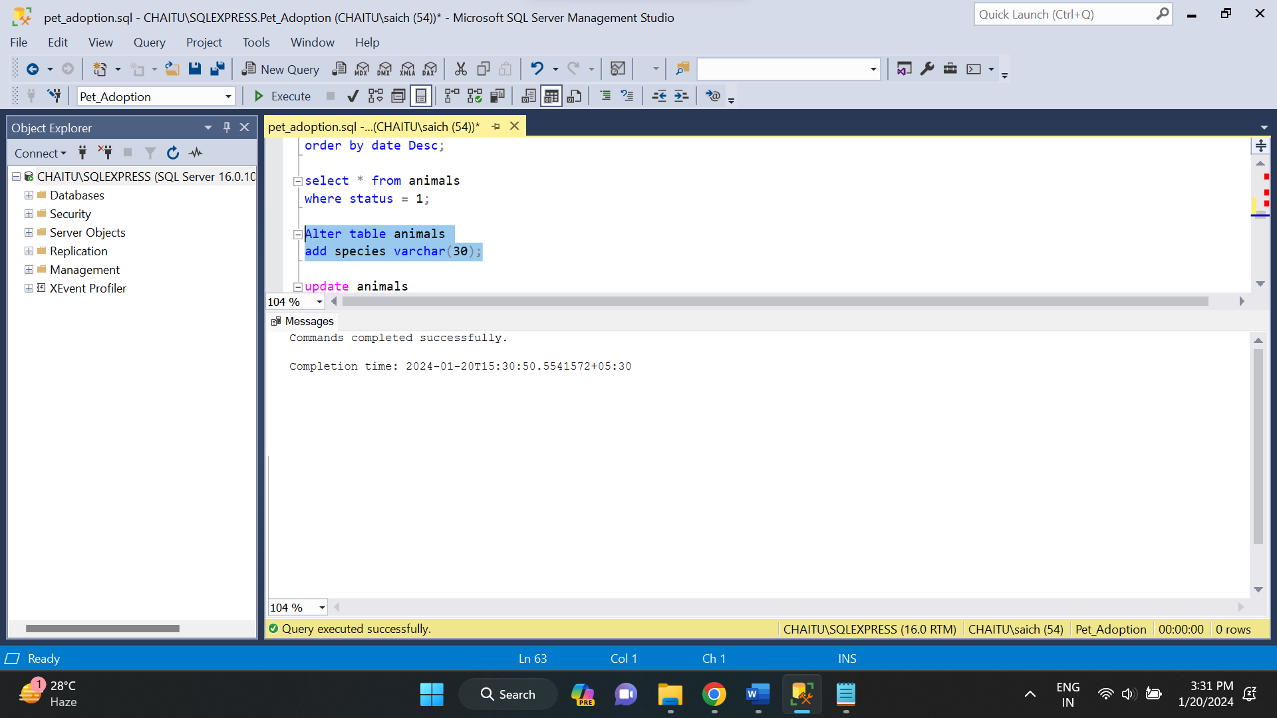

* **Drop:** This command is used to delete or remove the database objects. We can easily remove the entire table, view or index from the database.

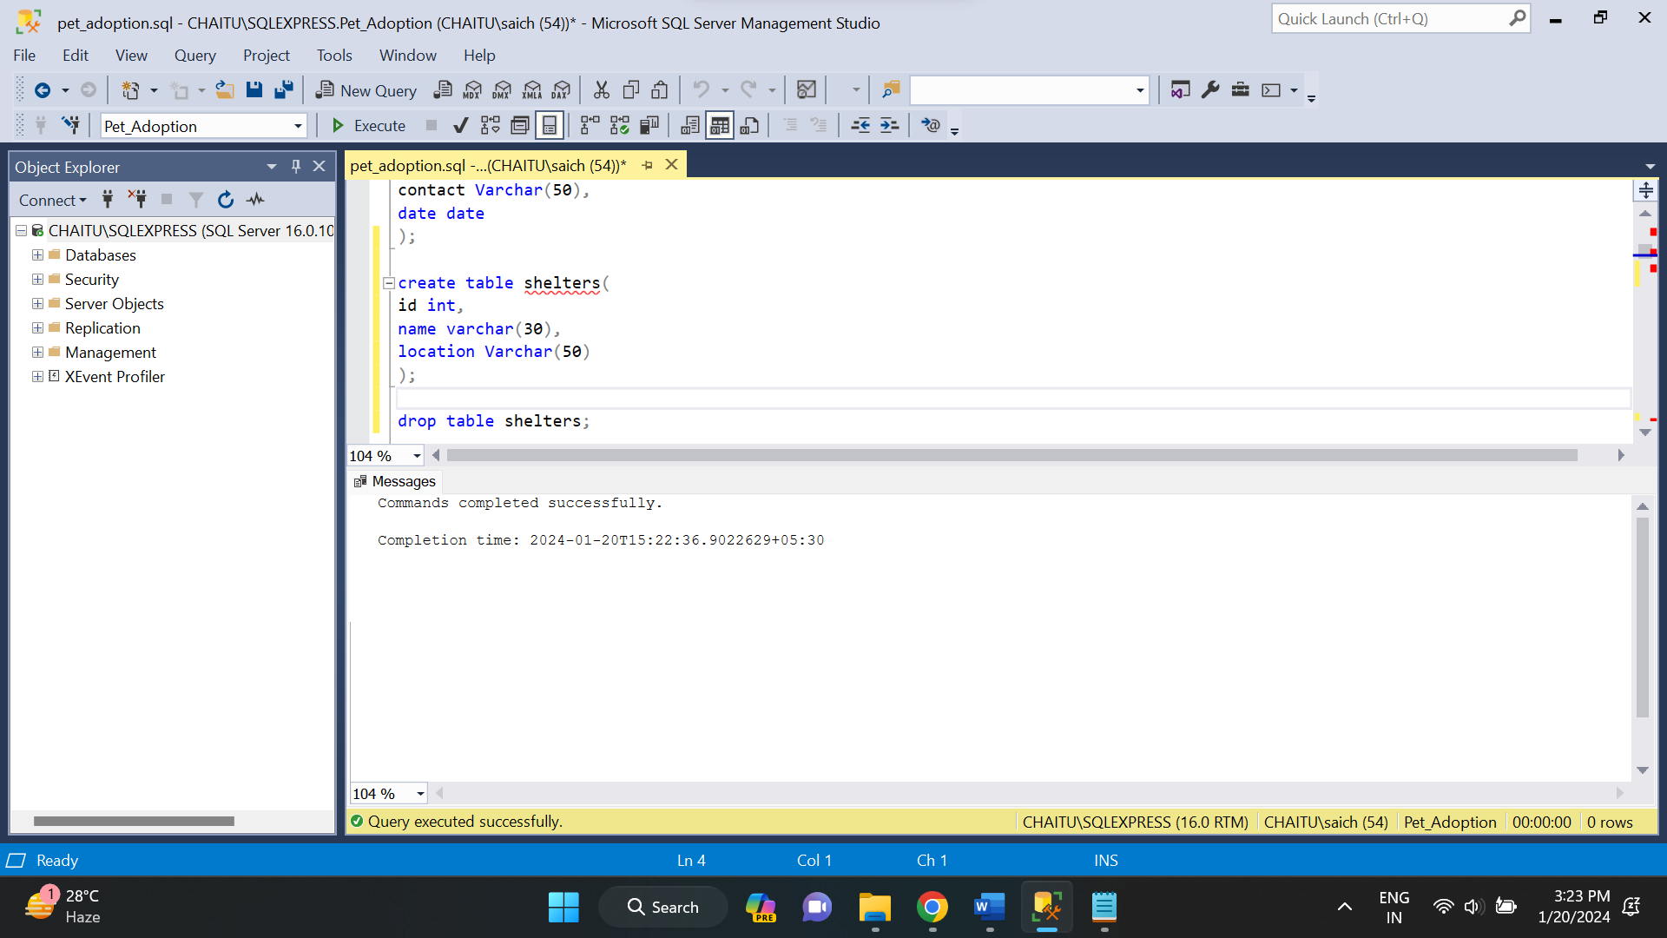

In the above picture, I have dropped shelters table.

* **Truncate:** This command deletes or removes all the records from the table. It also removes the space allocated for storing the table records.

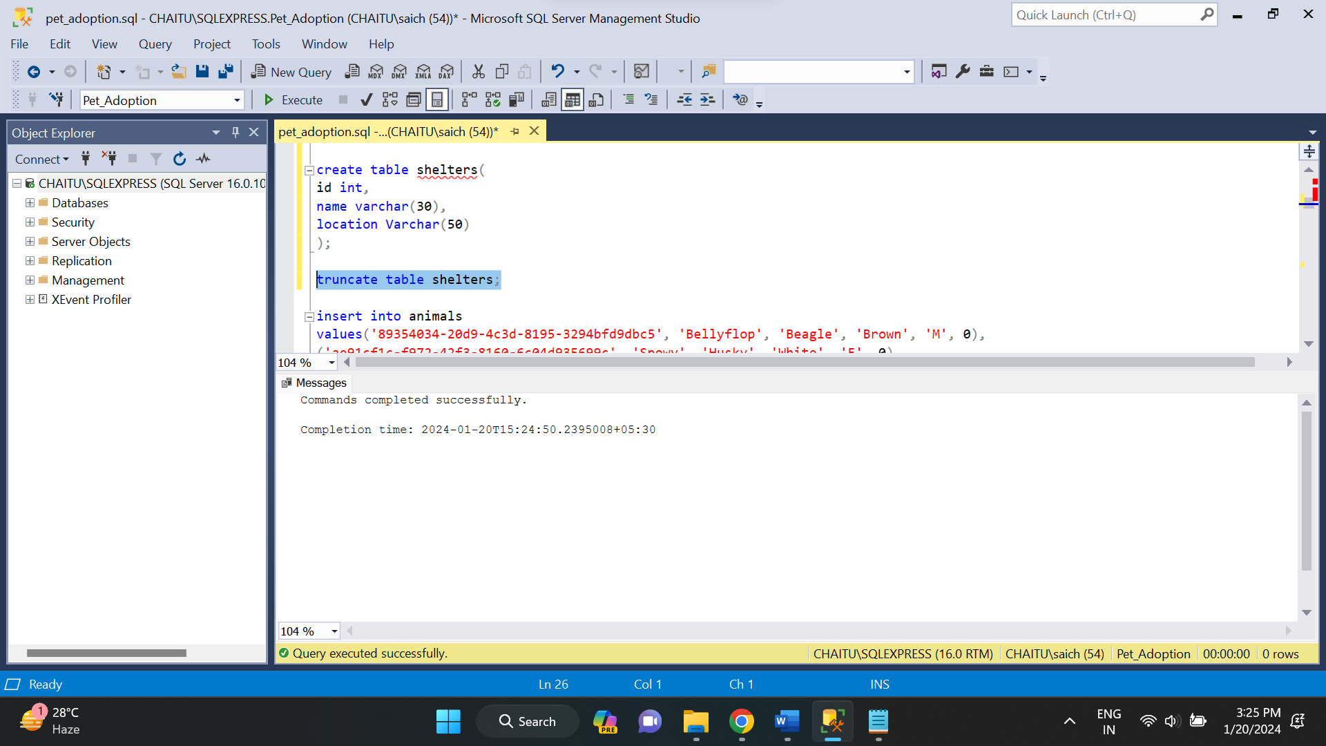

* **DML (Data Manipulation Language):**

DML, or Data Manipulation Language, consists of SQL statements used to manage data within the database. Unlike DDL (Data Definition Language), which deals with the structure of the database, DML focuses on the manipulation of data stored in the database.

The DML commands are:

* **SELECT:** This statement is used to retrieve data from one or more table in the database.

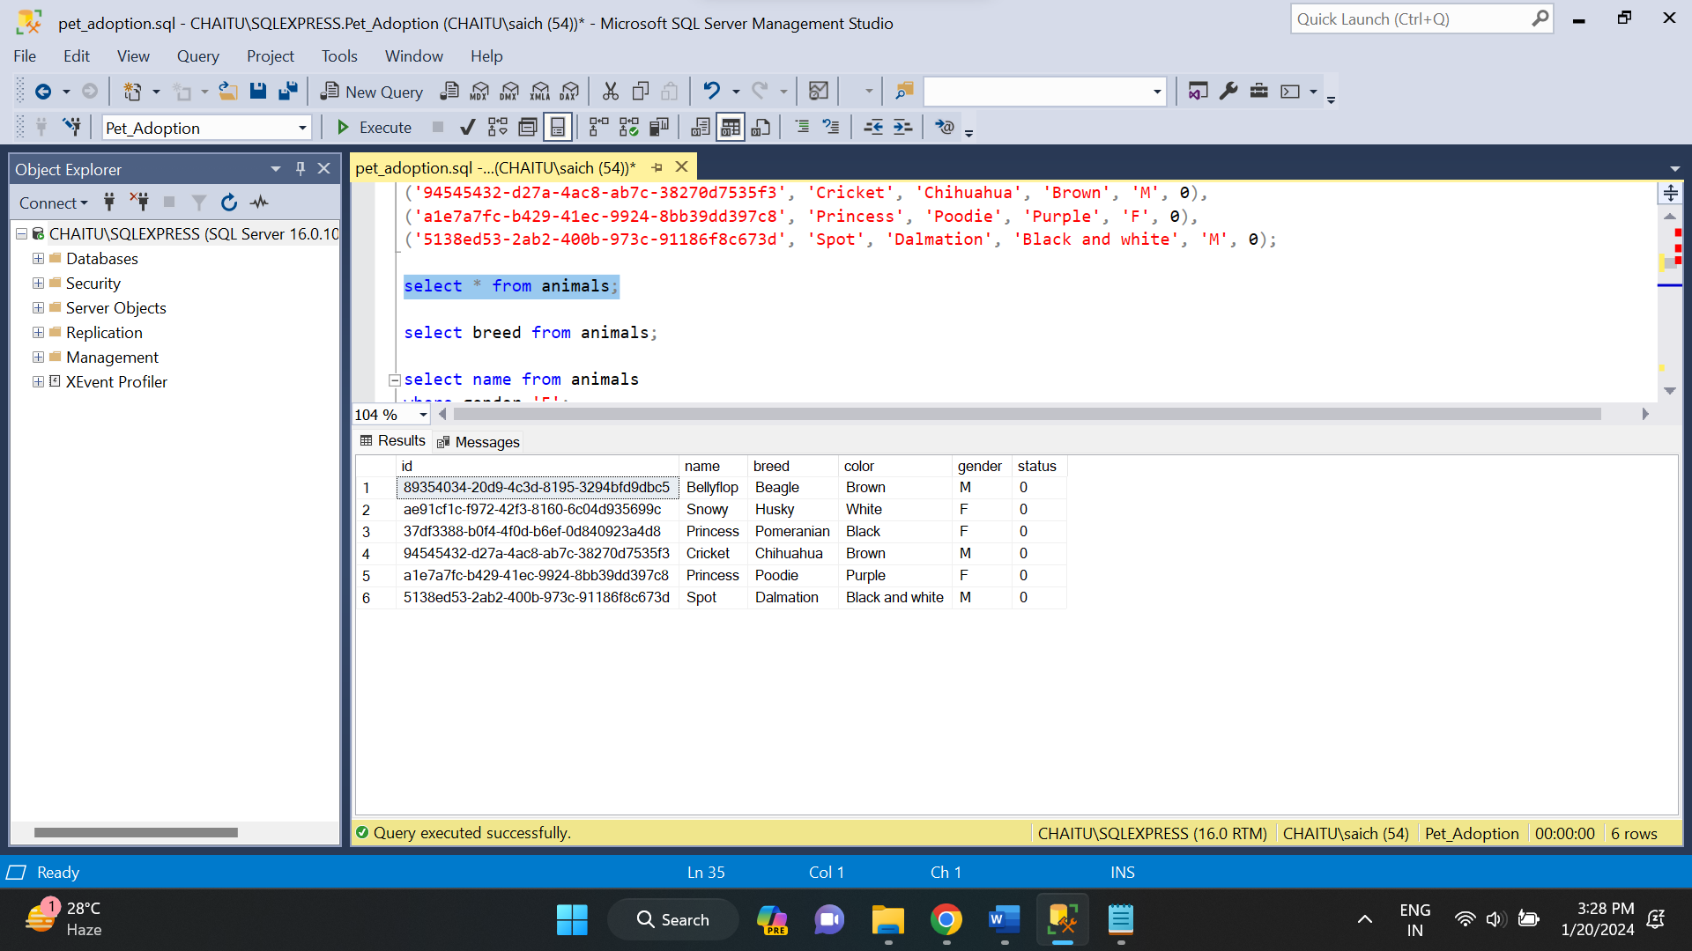

* **INSERT:** This statement is used to add more records into the table.

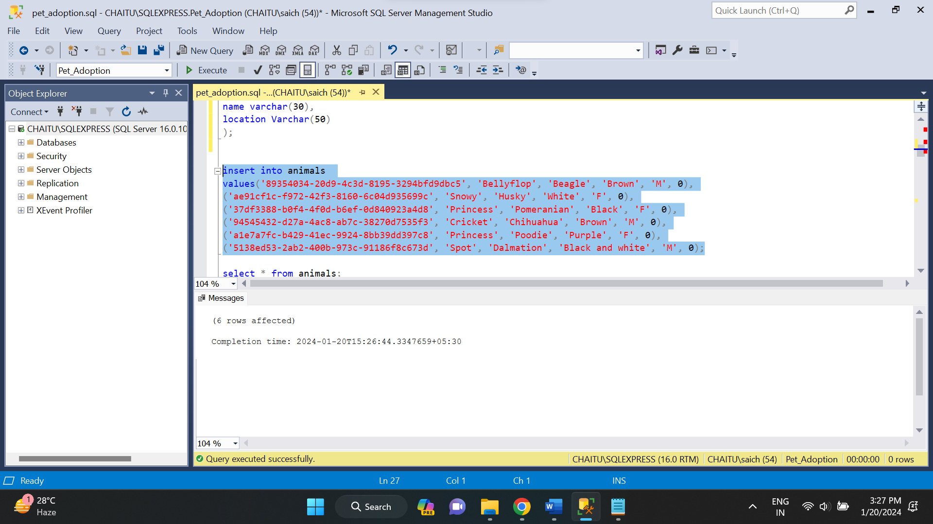

* **UPDATE:** This statement is used to modify existing records in the table.

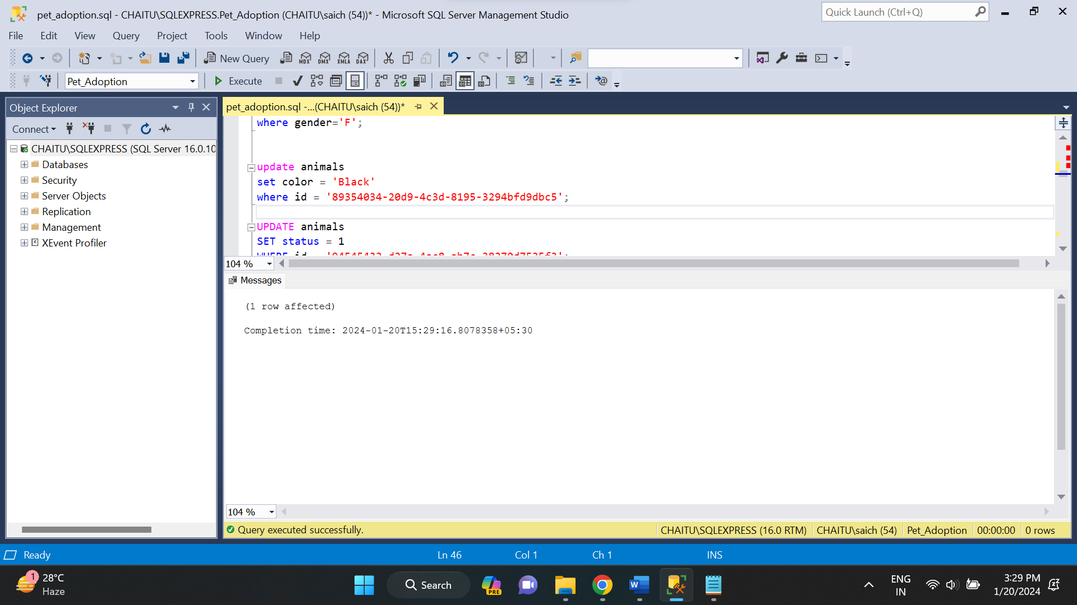

* **DELETE:** This statement is used to remove records from a table.

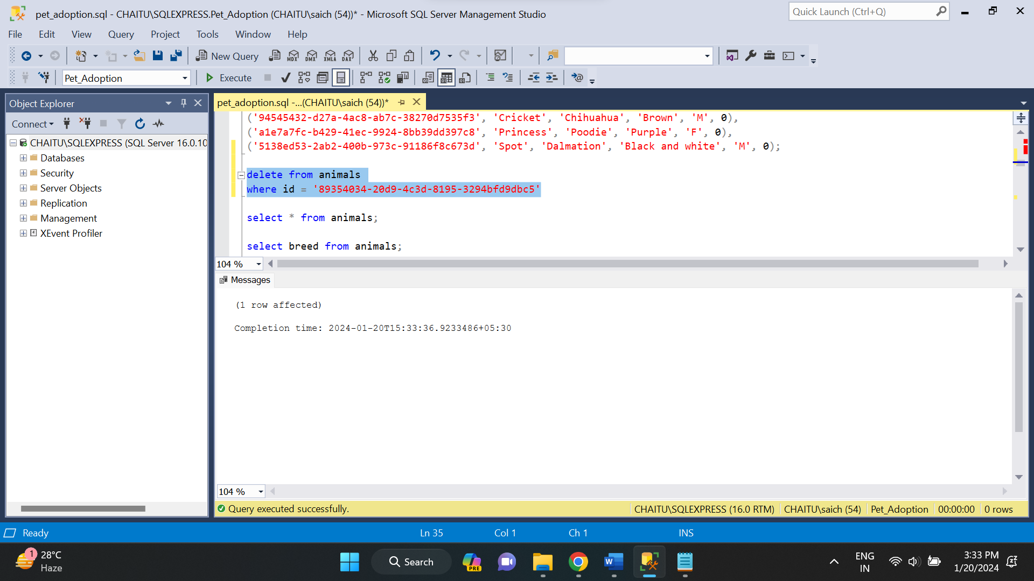

* **DCL (Data Control Language):**

DCL, or Data Control Language, consists of SQL statements used to control access to data within the database. DCL statements are primarily concerned with defining and managing permissions, as well as controlling transactions.

There are two DCL commands. They are:

* **GRANT:** The GRANT statement is used to give specific privileges or permissions to database users. These privileges could include the ability to SELECT, INSERT, UPDATE, DELETE, or execute other SQL commands on specific database objects.

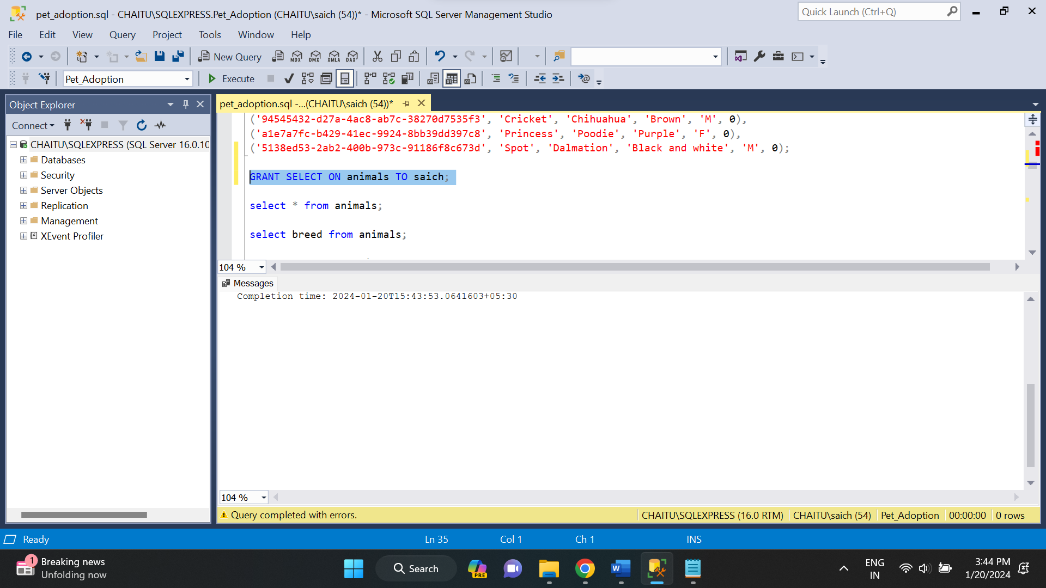

* **REVOKE:** The REVOKE statement is used to take back or remove previously granted permissions from a user or a role.

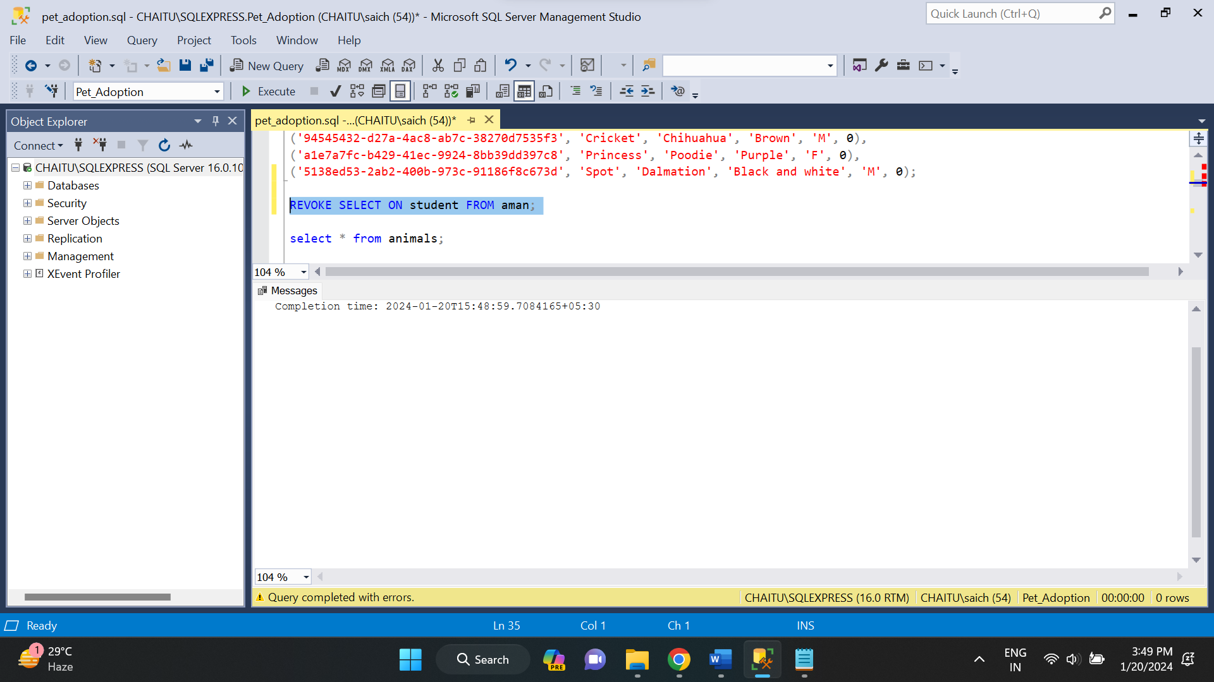

There are some operators in SQL. There are:

* **AND:** The AND operator is used to combine two or more conditions, and the combined condition is true only if all individual conditions are true.

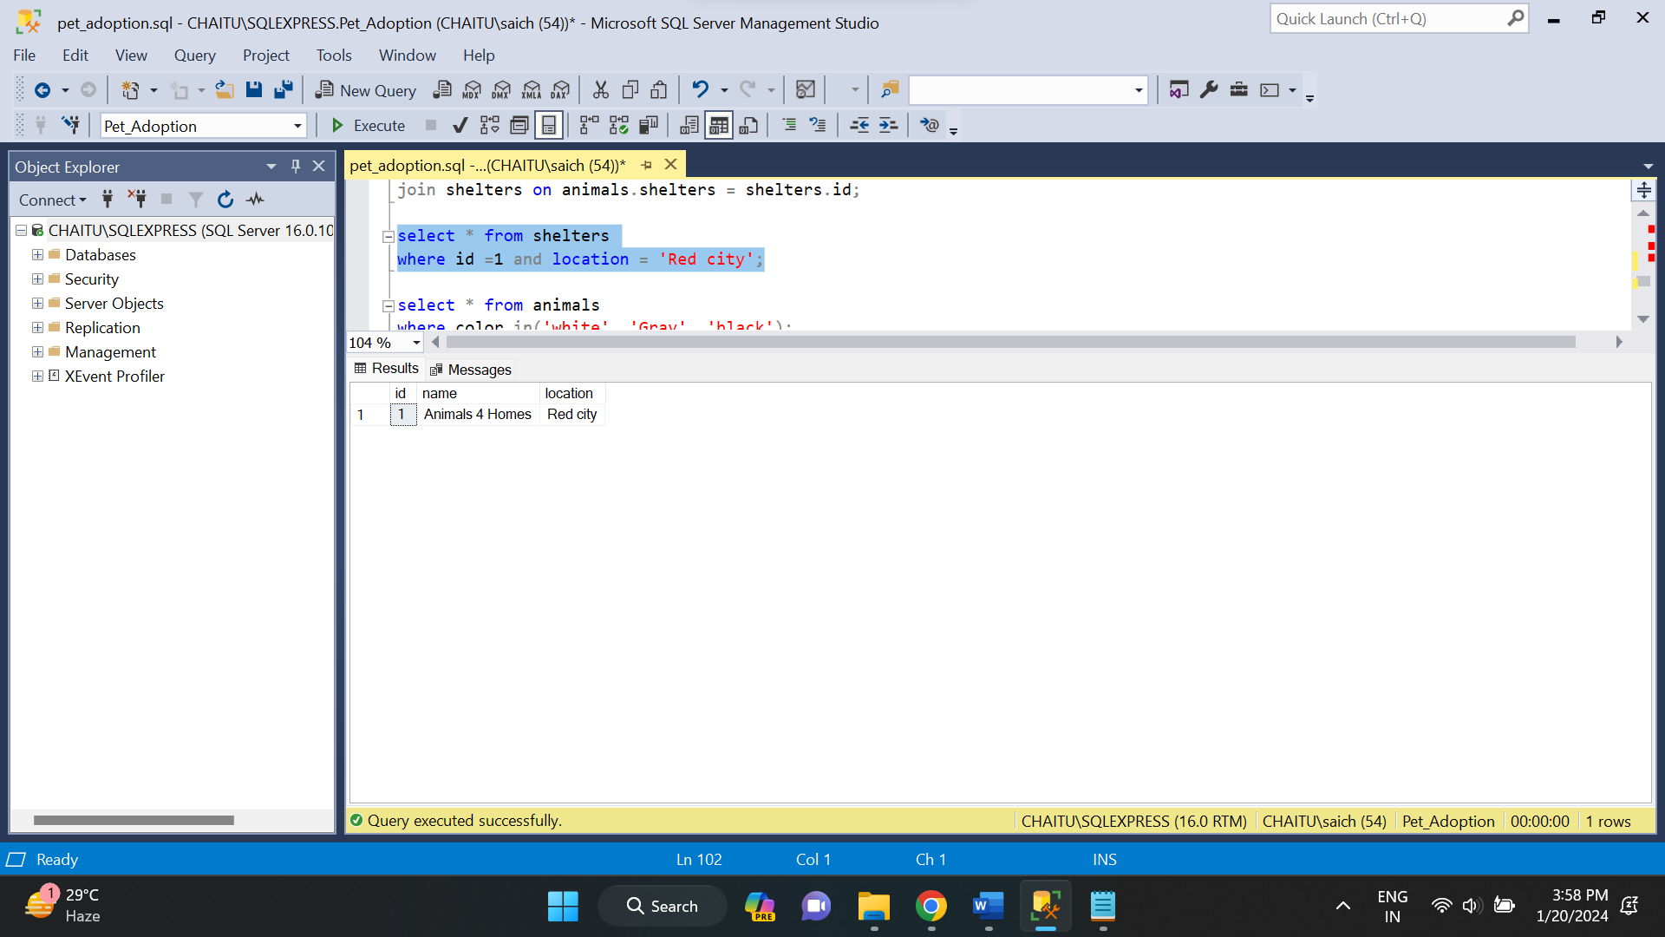

* **OR:** The OR operator is used to combine two or more conditions, and the combined condition is true if at least one of the individual conditions is true.

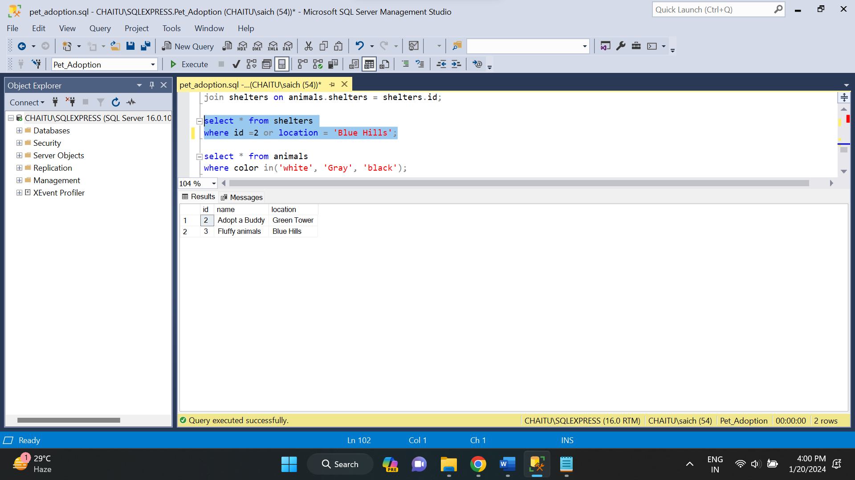

* **NOT**: The NOT operator is used to negate or reverse the result of a condition. If a condition is true, NOT will make it false, and if a condition is false, NOT will make it true.

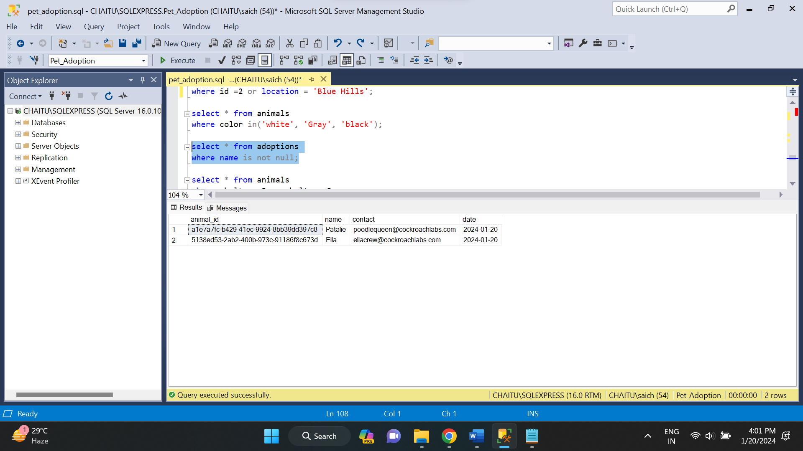

* **IN**: The IN operator is used to filter data based on a set of specific values. It checks whether a specified column's value matches any of the values in a list.

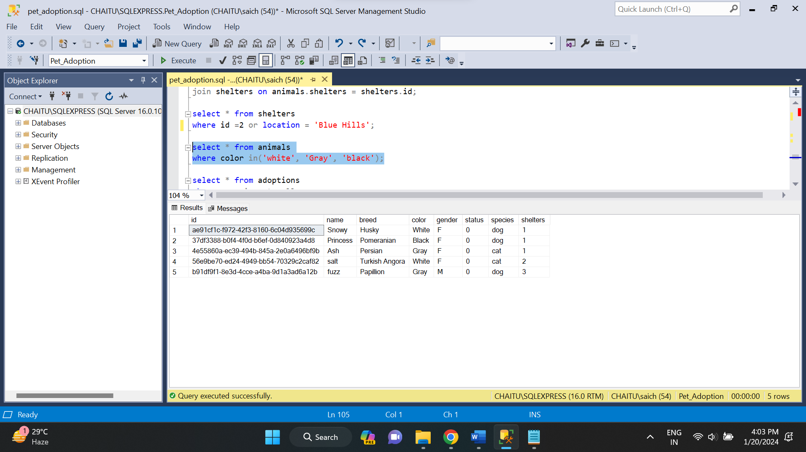

* **BETWEEN**: The BETWEEN operator is used to filter data within a specified range. It checks whether a column's value is within a specified range, including both endpoints.

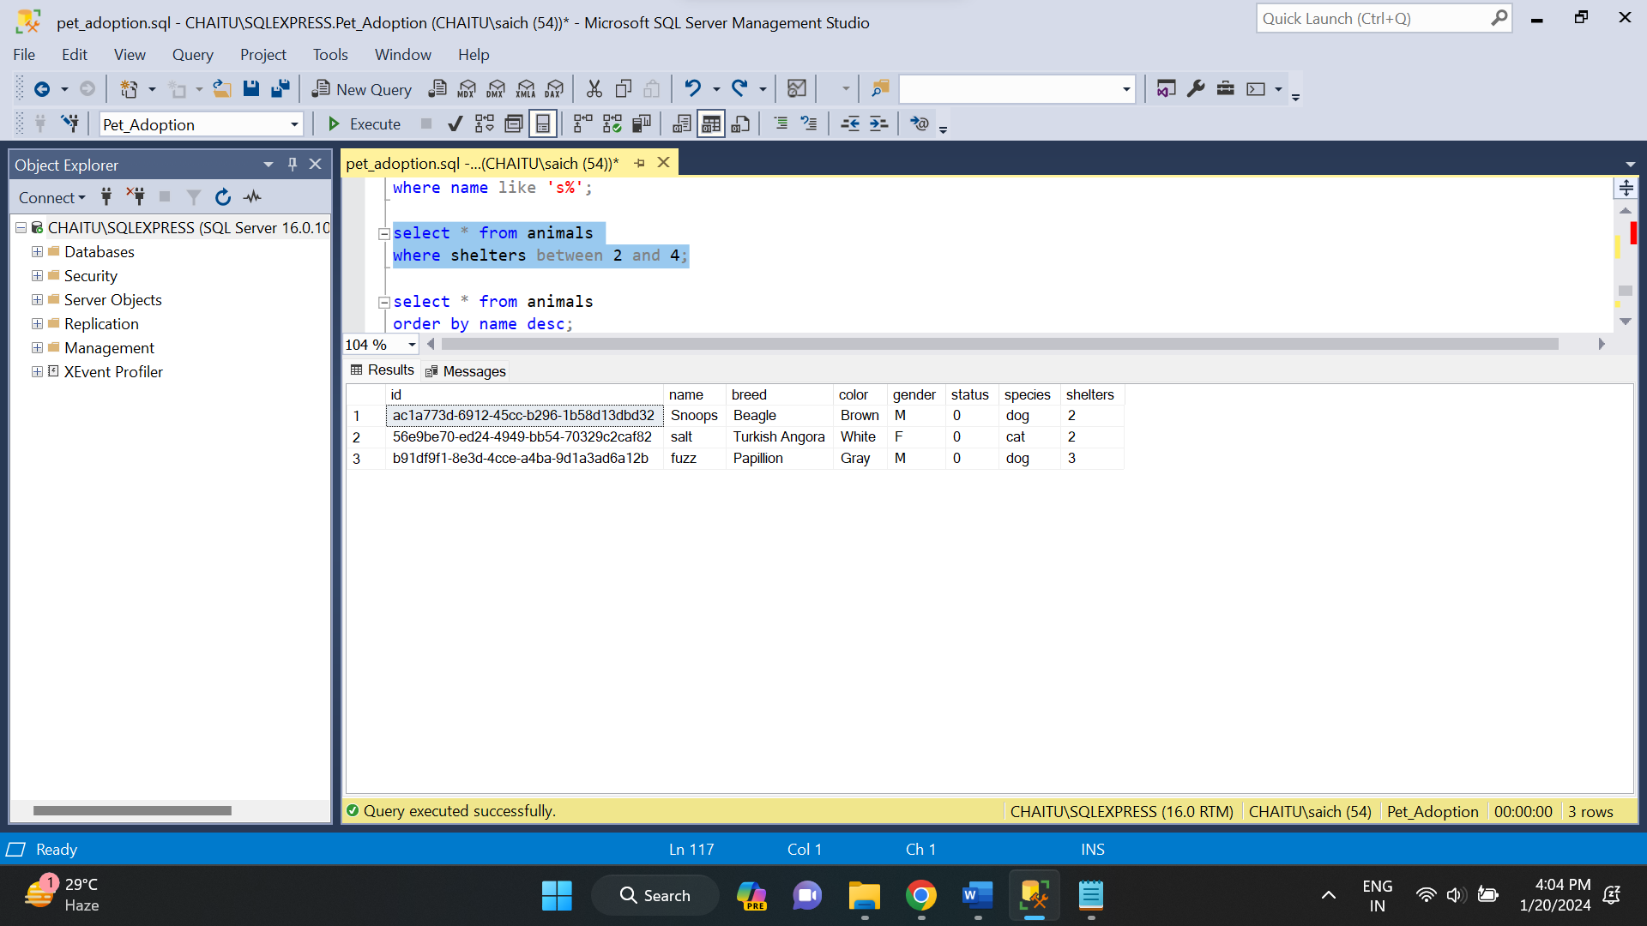

* **LIKE**: The LIKE operator is used to perform pattern matching in a string column. It is often used with wildcard characters, such as ‘%’ (matches any sequence of characters) and ‘_’ (matches any single character).

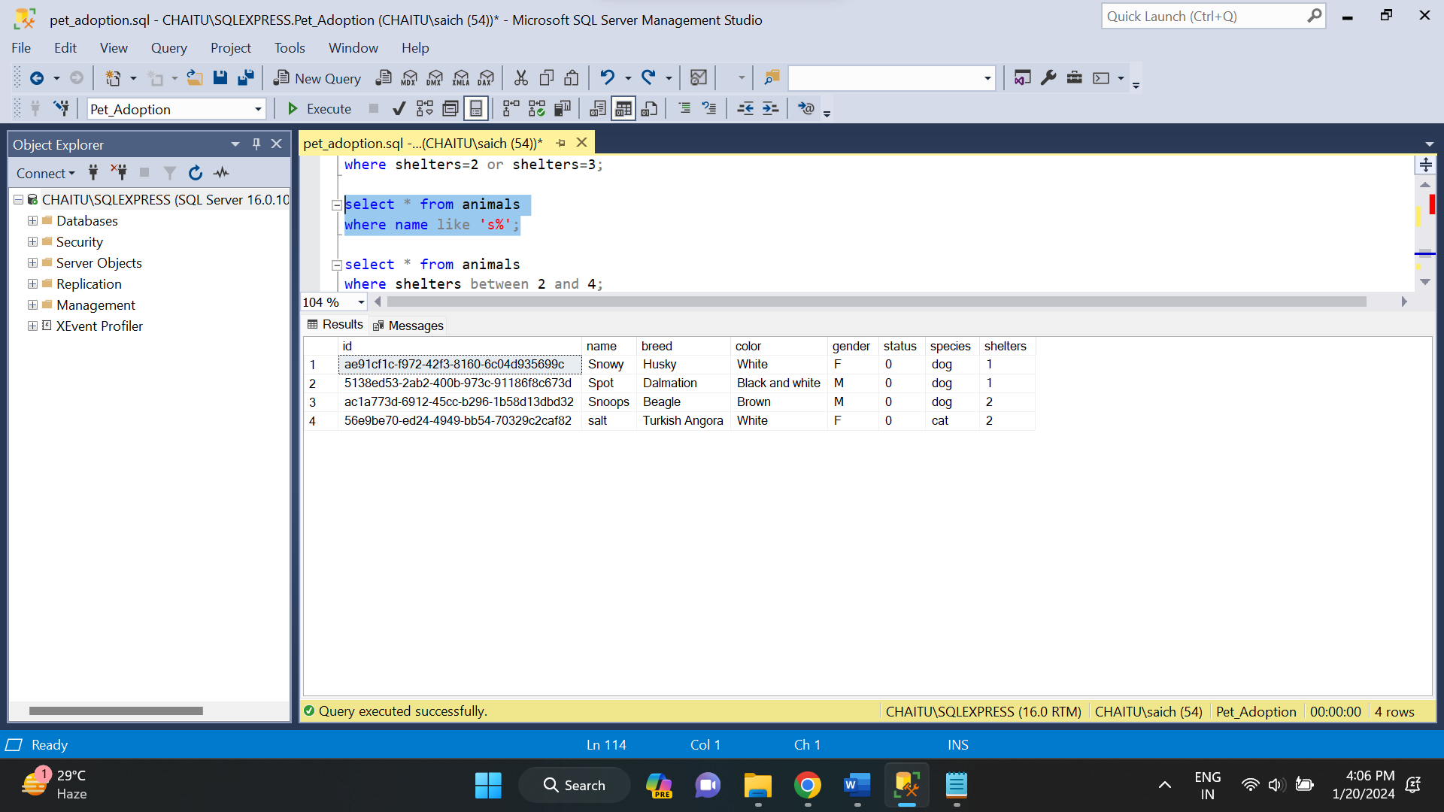

* **ALL**: The ALL operator is used to compare a value to all values in a set. It is often used with subqueries. The result is true if the comparison is true for all values in the set; otherwise, it is false.

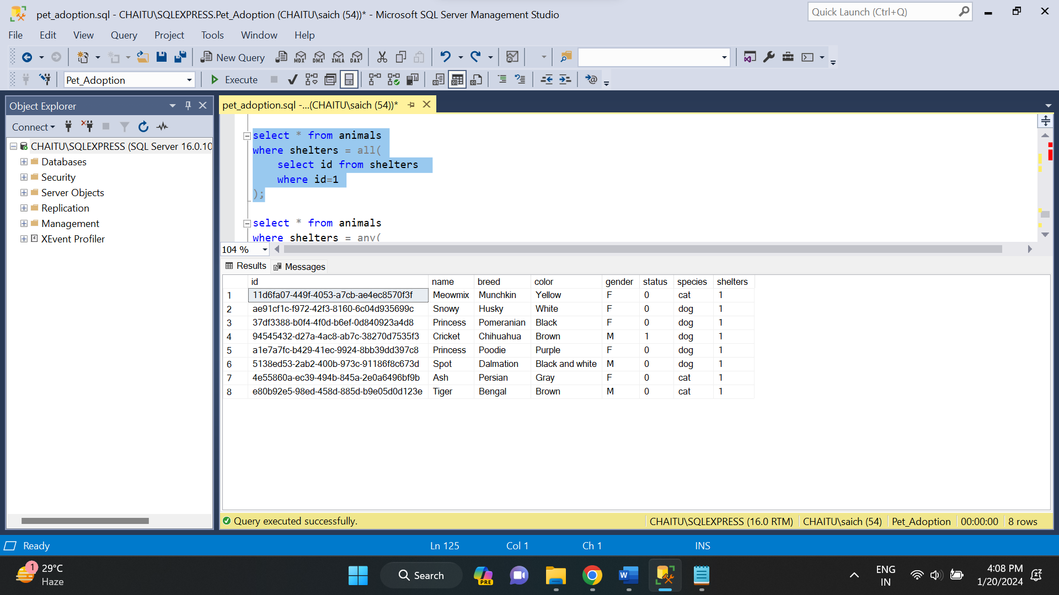

* **ANY**: The ANY operator is used to compare a value to any value in a set. It is often used with subqueries. The result is true if the comparison is true for at least one value in the set; otherwise, it is false.

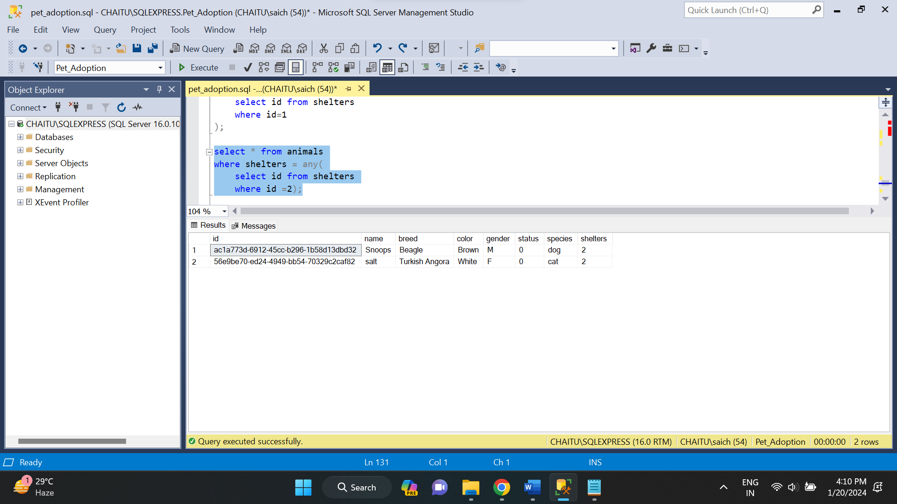

* **EXISTS**: The EXISTS operator is used to test the existence of rows in a subquery result. If the subquery returns any rows, the result is true; otherwise, it is false.

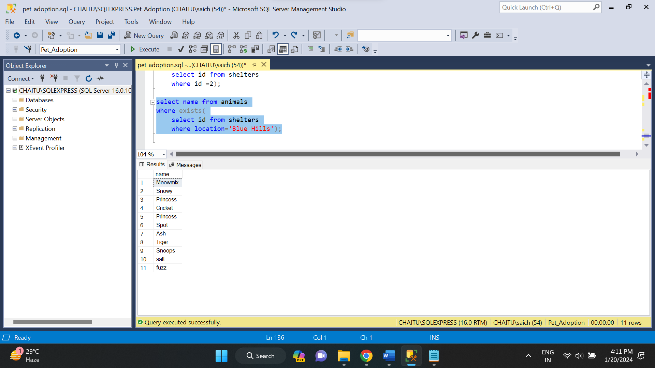

* **DISTINCT**: The DISTINCT keyword is used to eliminate duplicate rows from the result set of a query. It is often used with the SELECT statement to retrieve unique values from a specific column or combination of columns.

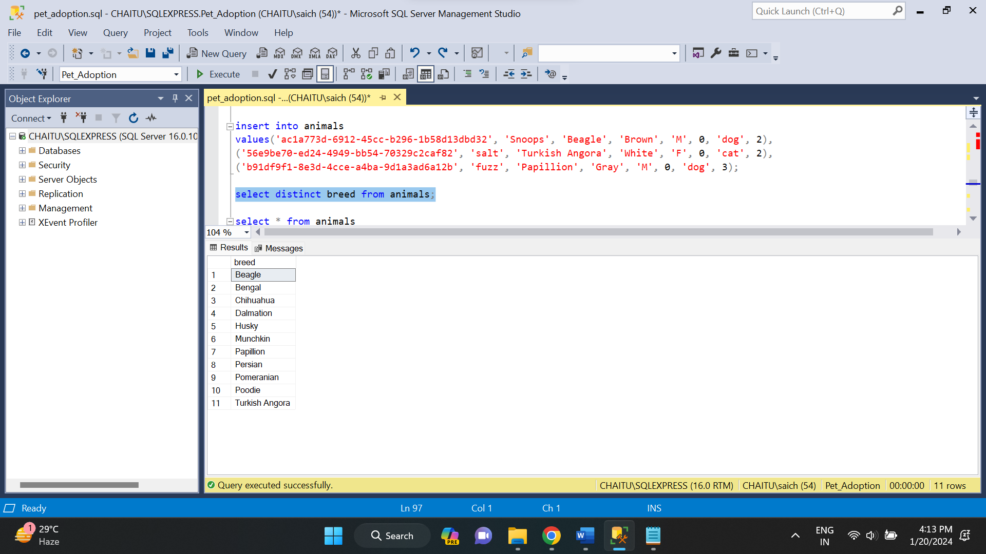

**JOINS:**

* **INNER JOIN:** The INNER JOIN keyword selects all rows from both the tables as long as the condition is satisfied. This keyword will create the result-set by combining all rows from both the tables where the condition satisfies.

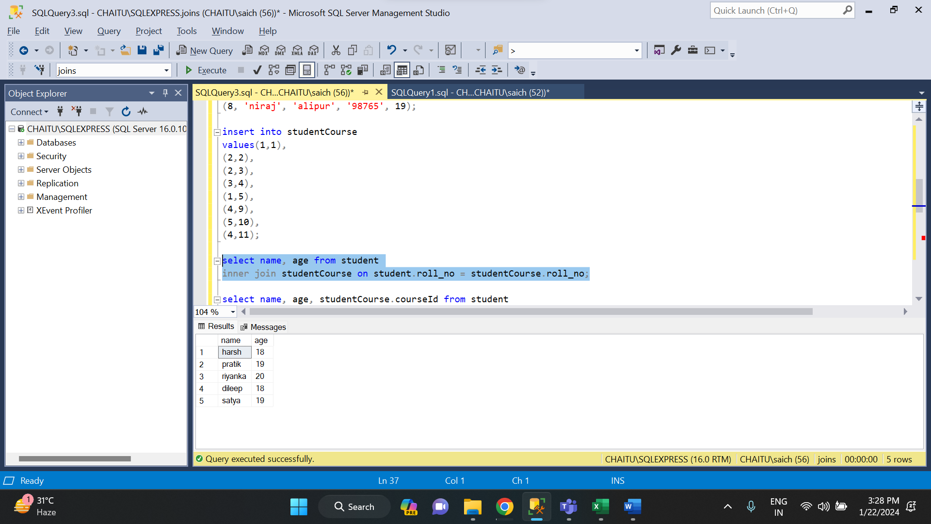

* **LEFT JOIN:** This join returns all the rows of the table on the left side of the join and matches rows for the table on the right side of the join.

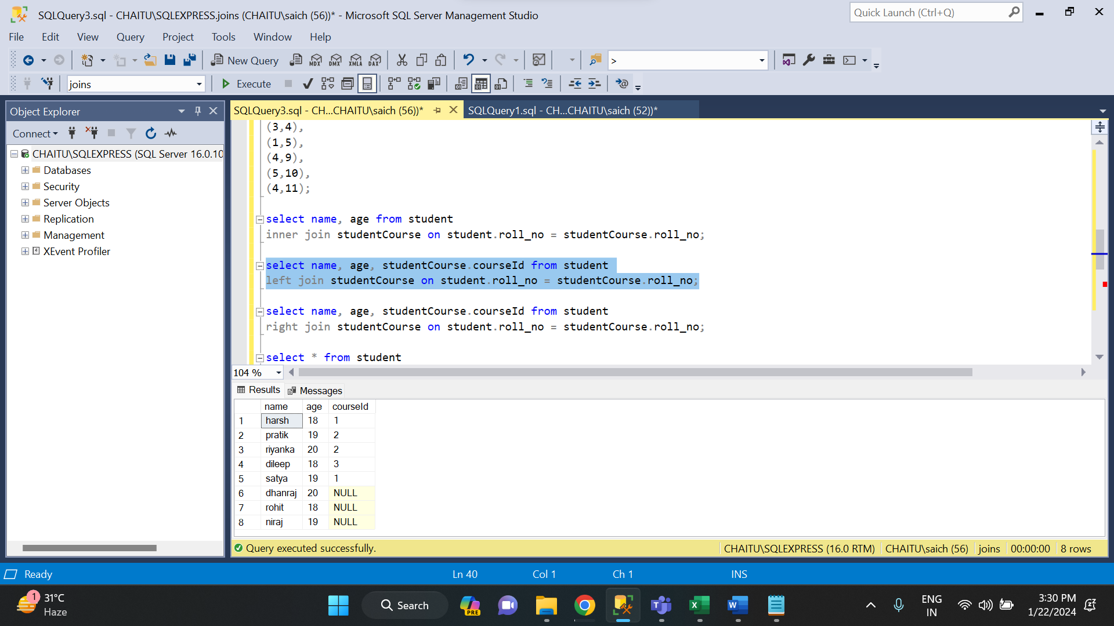

* **RIGHT JOIN:** RIGHT JOIN is similar to LEFT JOIN. This join returns all the rows of the table on the right side of the join and matching rows for the table on the left side of the join.

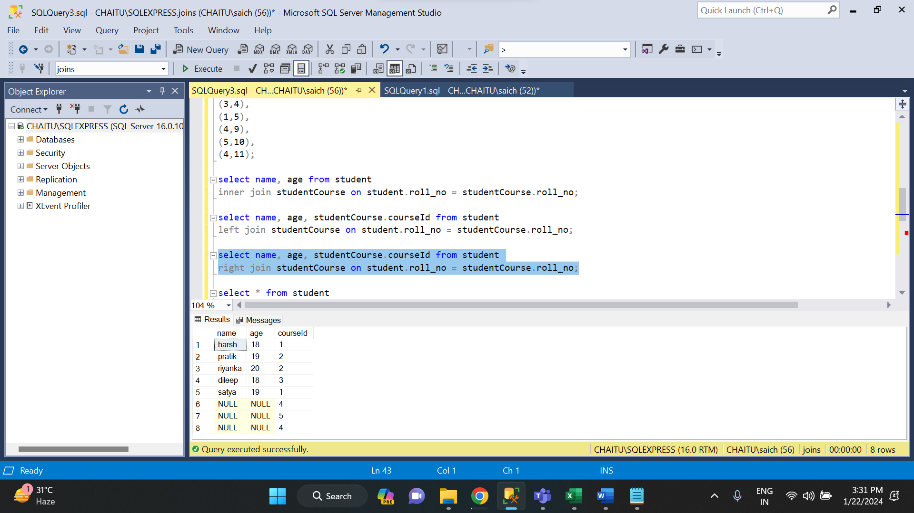

* **FULL JOIN:** FULL JOIN creates the result-set by combining results of both LEFT JOIN and RIGHT JOIN. The result-set will contain all the rows from both tables.

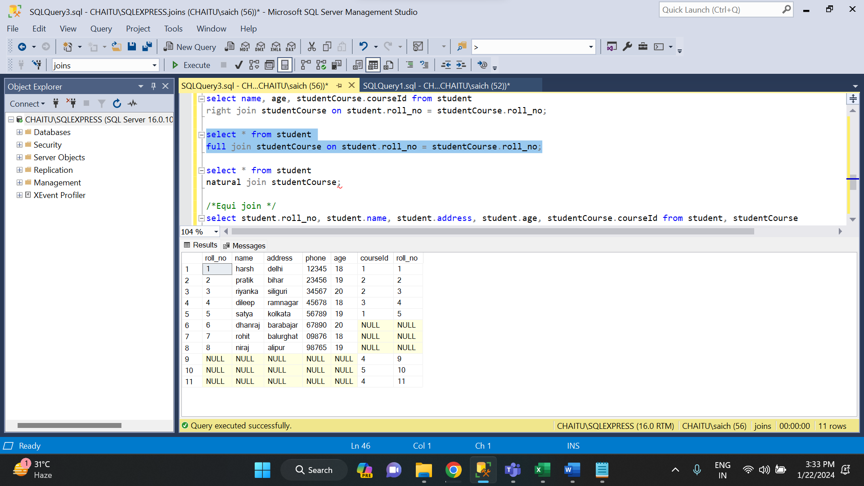

* **EQUI JOIN:** EQUI JOIN creates a JOIN for equality or matching column(s) values of the relative tables.

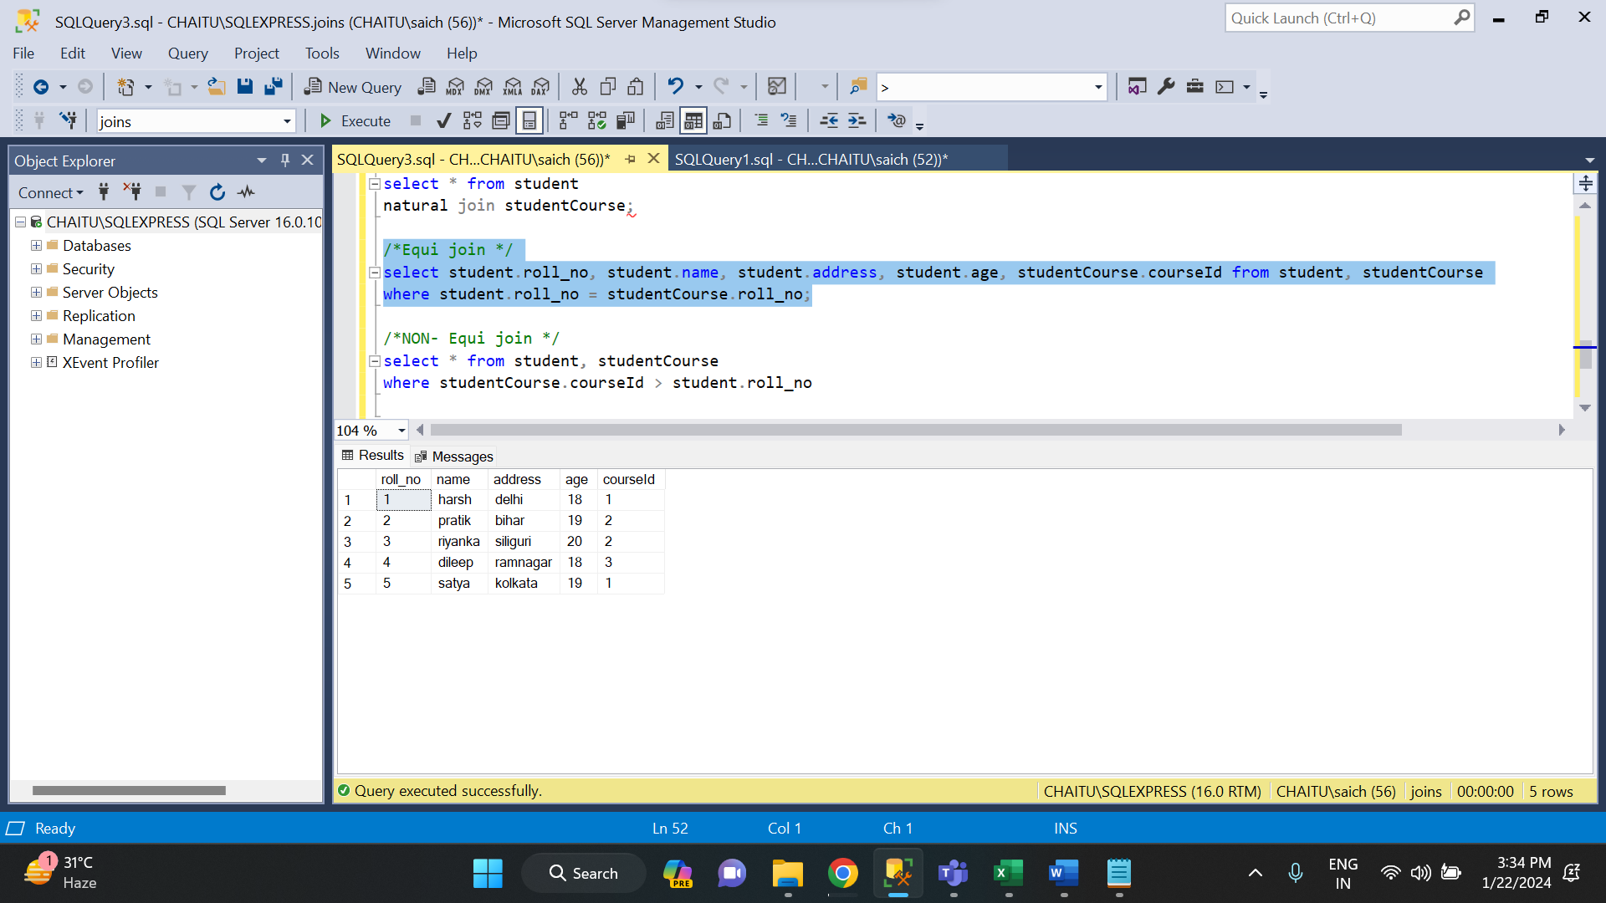

* **NON-EQUI JOIN:** NON EQUI JOIN performs a JOIN using comparison operator other than equal (=) sign like >, <, >=, <= with conditions.

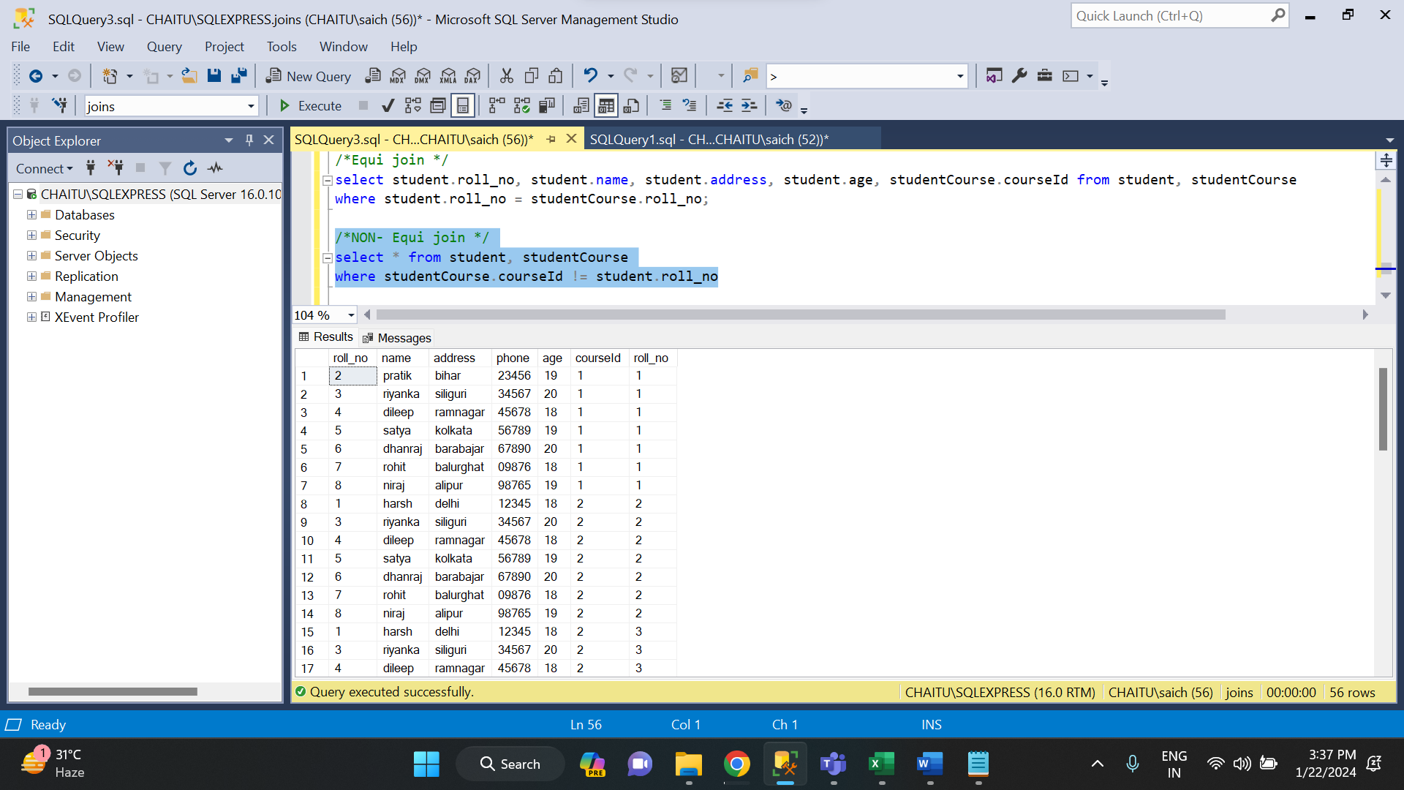

**CLAUSES IN SQL:**

* **GROUP BY:** The GROUP BY clause is used to group rows based on one or more columns. It is often used in conjunction with aggregate functions.

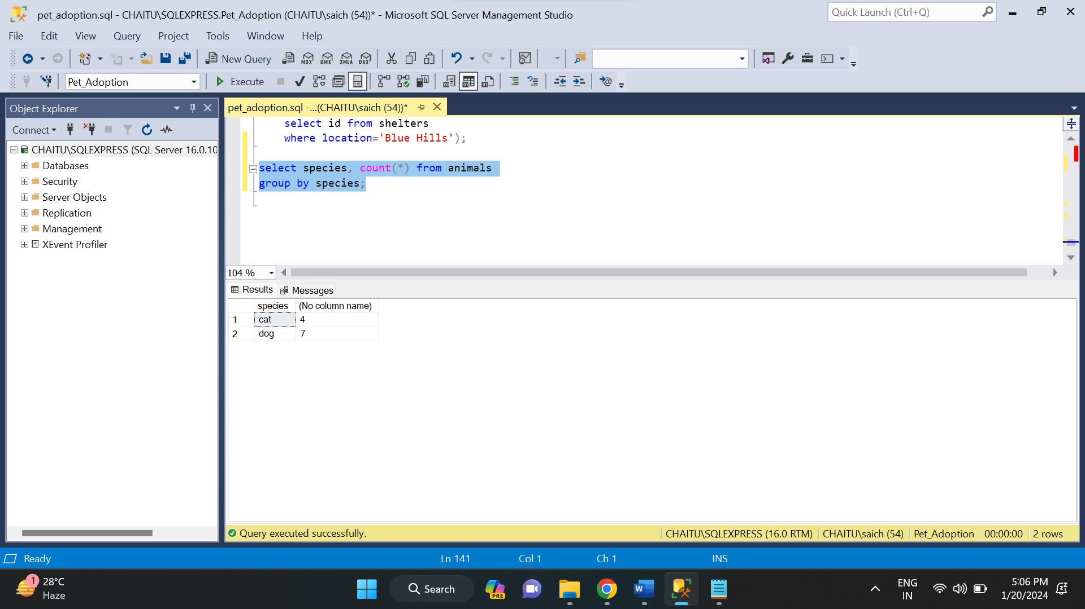

* **HAVING**: The HAVING clause is used in combination with GROUP BY to filter the groups based on aggregate function results. It is similar to the WHERE clause but is used with aggregated data.

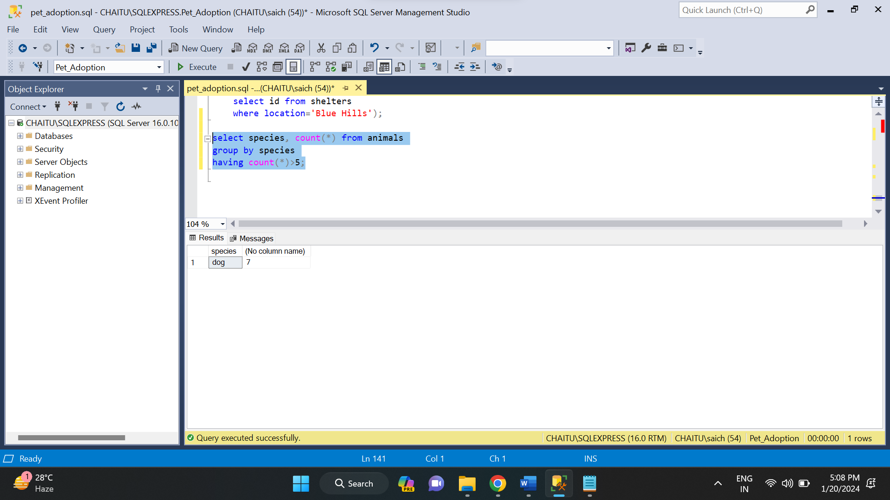

* **ORDER BY:** The ORDER BY clause is used to sort the result set based on one or more columns, either in ascending (ASC) or descending (DESC) order.

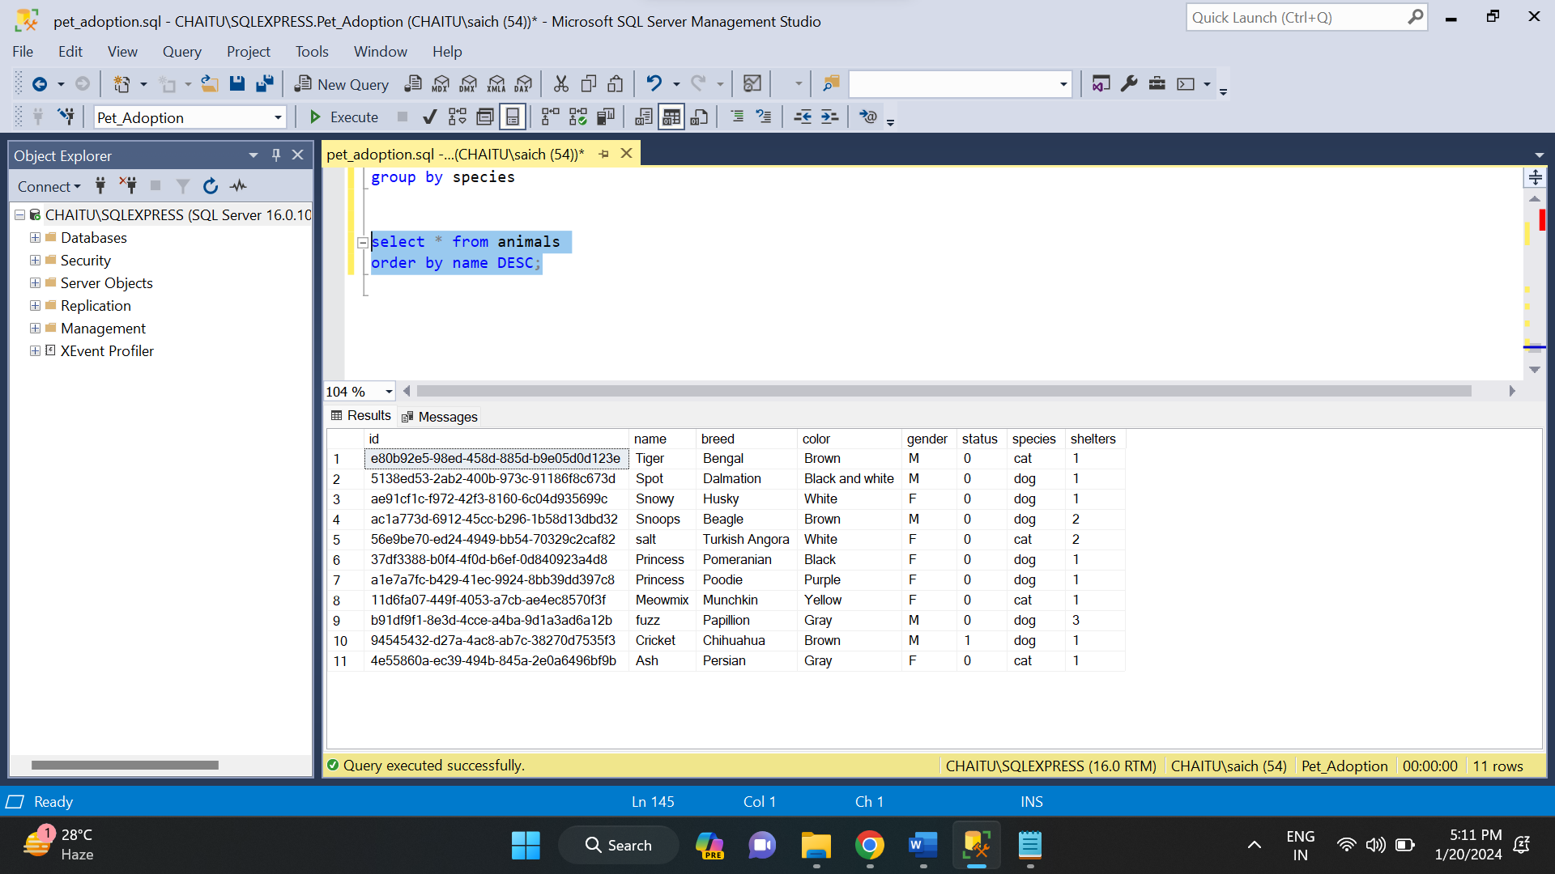

SET OPERATORS IN SQL:

* **UNION**: UNION will be used to combine the result of two select statements. Duplicate rows will be eliminated from the results obtained after performing the UNION operation.

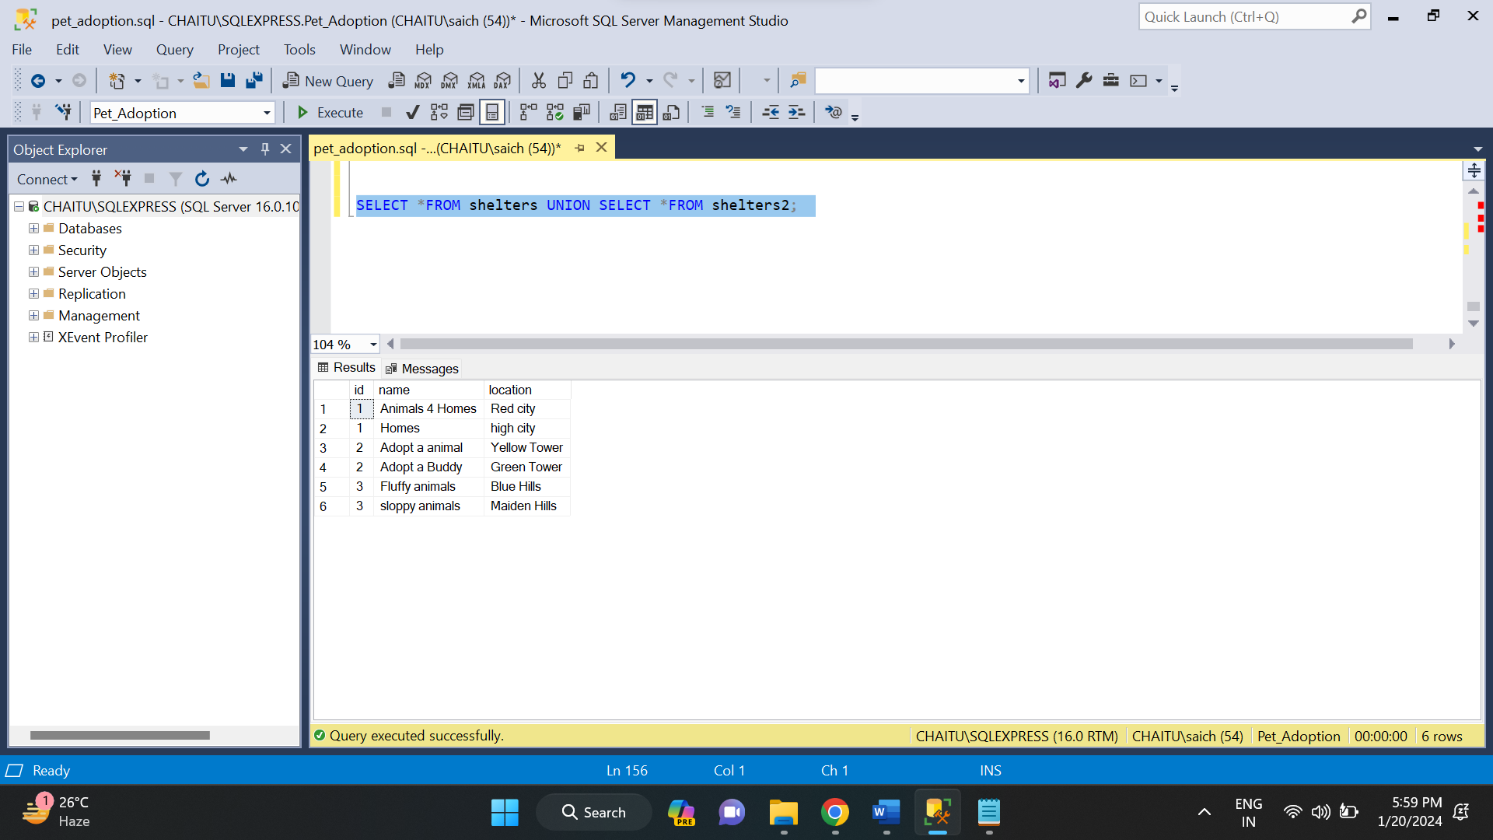

* **UNION ALL:** This operator combines all the records from both the queries. Duplicate rows will be not be eliminated from the results obtained after performing the UNION ALL operation.

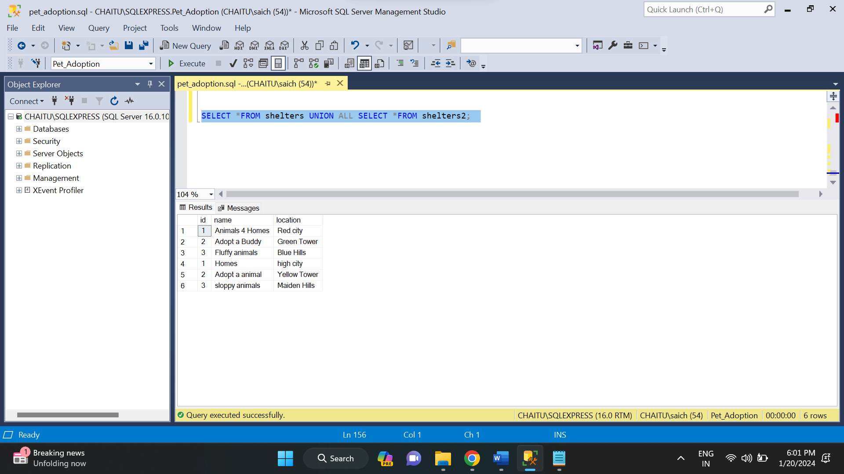

* **INTERSECT:** It is used to combine two SELECT statements, but it only returns the records which are common from both SELECT statements.

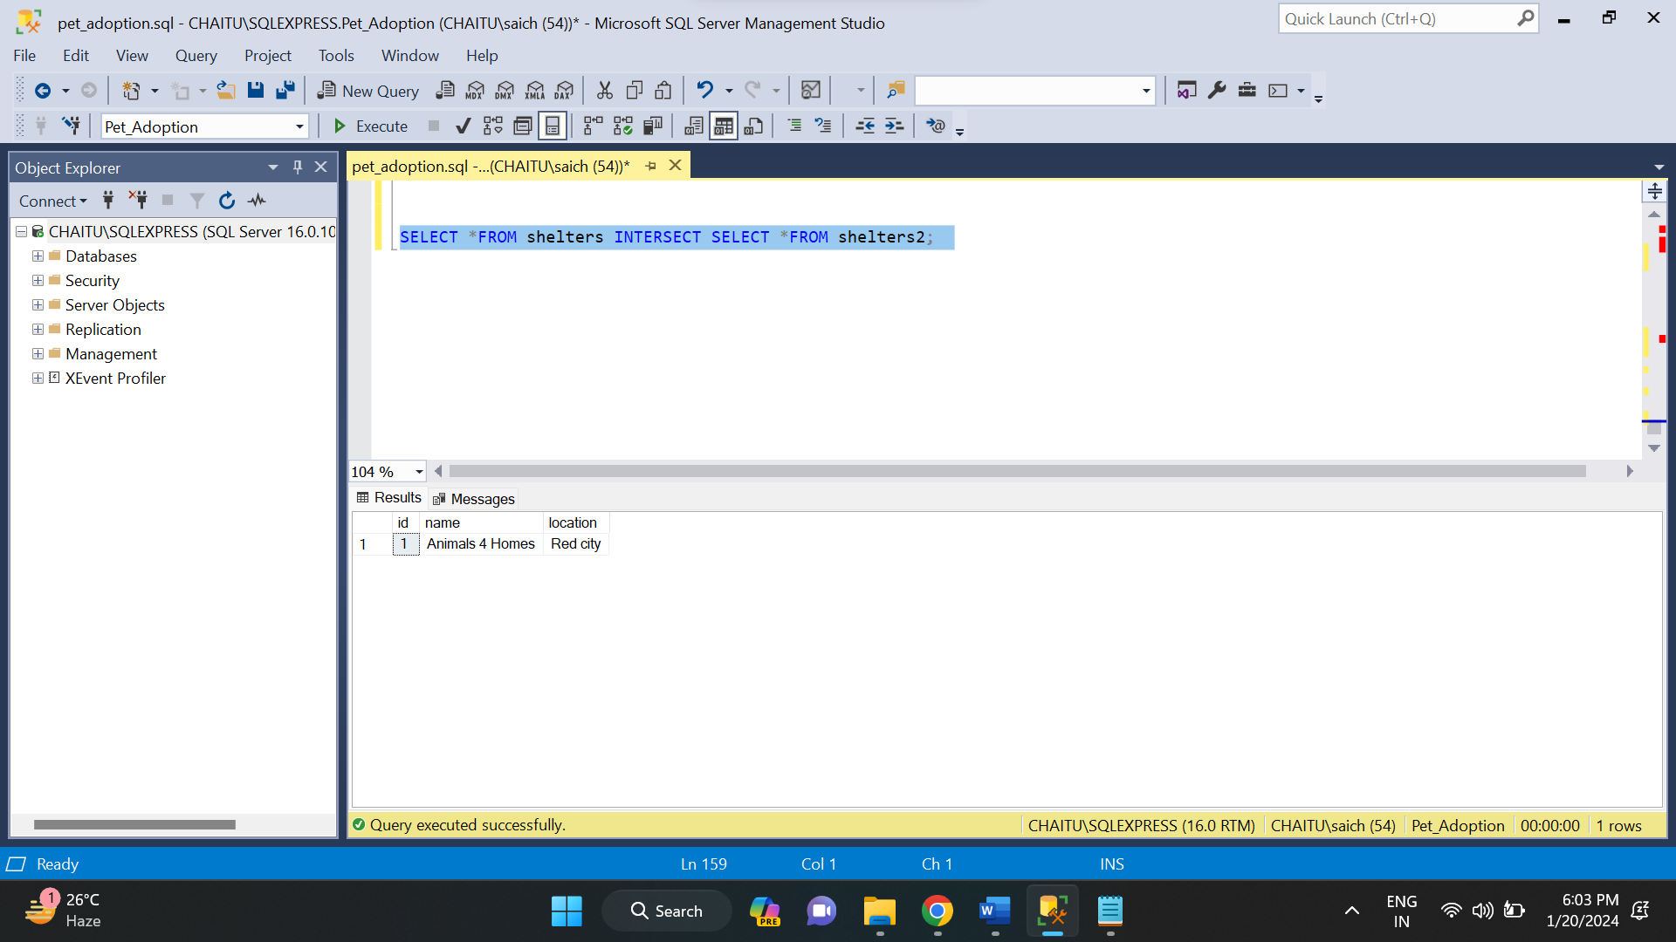

* **MINUS:** It displays the rows which are present in the first query but absent in the second query with no duplicates.

